MEDICAL TERMINOLOGY: Chapter 1 Notes
The Basics and the Body
Anatomy-
Physiology-
Body Planes-
Body Directions-
Anatomical Position (also known as _________________________position):
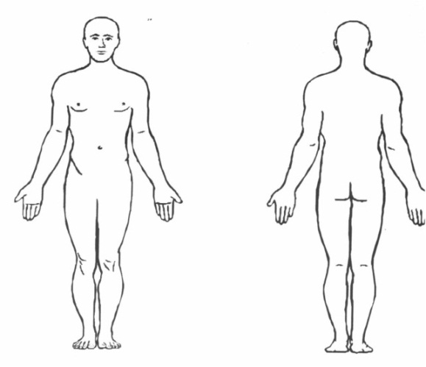
Body Planes (define- what does each it divide the body into?)
- Sagittal-
  - Midsagittal-
- Frontal/Coronal-
- Transverse-
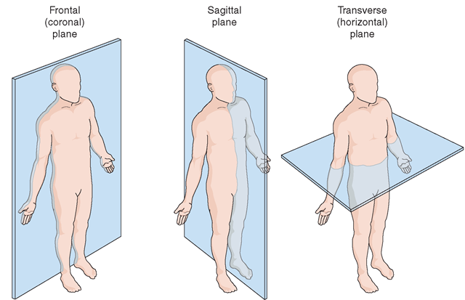
[Type a quote from the document or the summary of an interesting point. You can position the text box anywhere in the document. Use the Drawing Tools tab to change the formatting of the pull quote text box.]
Body Directions (define)
- Ventral-
- Dorsal-

- Anterior-
- Posterior-

- Superior-
- Inferior-

- Medial-
- Lateral-

- Proximal-
- Distal-

- Caudal-
- Cephalic-

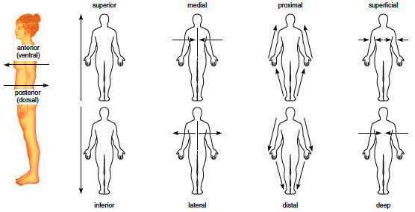

Body Cavities (describe each and list organs they may contain)

_______________Cavities:
- Cranial-
- Spinal-

________________Cavities:
- Thoracic
- Abdominal
- Pelvic

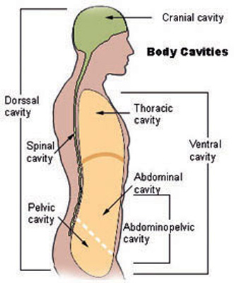

Abdominal Quadrants (know the abbreviations for each!)

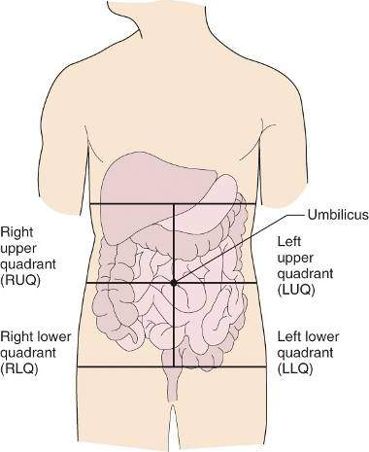

Abdominal Regions

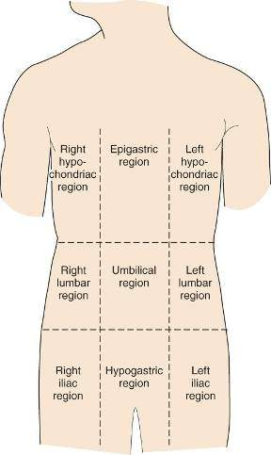

Body Organization
- Cell
- Tissue
- Organ
- Body System
- Organism
The Body Systems (describe the function and parts of each)
- Integumentary

- Digestive

- Lymphatic or_______________

- Muscular

- Skeletal

- Cardiovascular or ___________________

- Respiratory

- Urinary or _________________

- Nervous

- Reproductive

Patient Positions (Label each and describe what it may be used for):
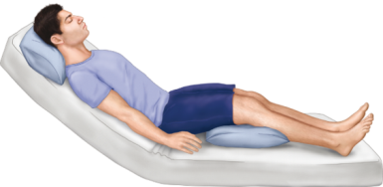

Descriptive Vocabulary for Diseases/Conditions & Assessments
- Acute
- Autoimmune
- Benign
- Chronic
- Congenital
- Convalescence
- Debilitating
- Endemic
- Endogenous
- Epidemic
- Exogenous
- Genetic
- Hypersensitivity
- Idiopathic
- Immunological
- Infectious
- Inflammatory
- Ischemic
- Malignant
- Metabolic
- Neoplastic
- Nosocomial
- Nutritional
- Opportunistic
- Syndrome
- Terminal
- Iatrogenic
- Inspection
- Auscultation
- Signs
- Symptoms
- Palpation
- Percussion
- Olfaction
- Manifestation
- Observation
- Diagnosis
- Prognosis

