Name:
Medical Terminology : Skeletal System Test Review
Color the axial skeleton red and the appendicular skeleton blue:
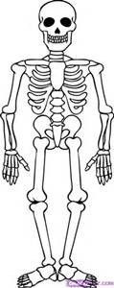
Give 2 examples of each type of bone:

- long-
- flat-
- irregular-
- sesamoid-
- short-

Describe each therapy/procedure/medication:
- NSAID
- Narcotic
- Analgesic
- Antipyretic
- Lumbar puncture
- Amputation
- Prosthesis
- Cast
- ORIF

Draw a long bone and label the following:
Endosteum Periosteum Medullary Cavity
compact bone spongy bone epiphyses diaphysis

Long bone diagram (draw/label):

Describe each type of fracture (and the bone where it most commonly occurs and how it is caused):
- comminuted
- greenstick
- compression
- pathological
- spiral
- stress
- Colles
- simple
- complex

Define each disease/disorder/injury of the bone:
- avulsion
- dislocation

Label the bones of the skeleton below (on your chapter cover page in journal):
clavicle cranium
radius tibia
scapula calcaneus
metacarpals pelvis
femur maxilla
fibula vertebrae
humerus ulna
mandible patella
tibia phalanges
carpals metatarsals
metatarsals carpals
phalanges tarsals

