MEDICAL TERMINOLOGY: Cardiovascular System Notes
Functions of the cardiovascular system:
The 3 major structures of the Cardiovascular System:

Chambers of the Heart
*Be able to label (know location of each)

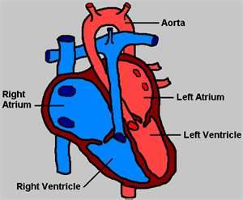
What is the aorta? (hint: type of structure/function…what is special about it)
Muscular Layers of the Heart (label the diagram)
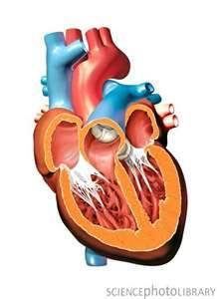
Describe the heart (first) and its parts:

- epicardium
- myocardium
- endocardium
- chambers of the heart (list)

- List the four valves of the heart

Define
- circulation:

  - pulmonary

  - systemic:
    - List the pathway as blood flows through the heart:

- conduction:

- blood pressure:
  - systolic BP:
  - diastolic BP:
  - sphygmomanometer:

Define Pulse:
Label the Pulse Points
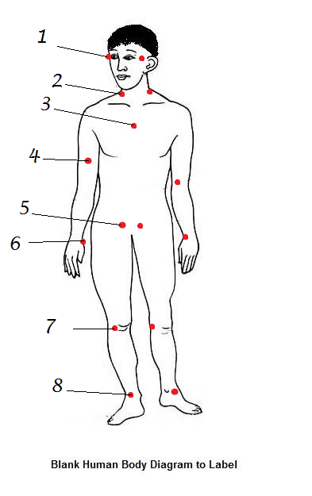

Used to take blood pressure:__________________________________
Pulse that requires a stethoscope:______________________________________
Most common pulse point:____________________________________
DRAW THE HEART

- Draw the heart below labeling the following structures:
Bicuspid Valve Ventricles ( right & left) Pulmonary veins Pericardium Aortic valve Atria (right & left) Pulmonary arteries Myocardium Septum
Vena Cava (superior & inferior) Ascending Aorta Descending Aorta Endocardium AV node
SA node Tricuspid valve Pulmonary valve

- Show blood flow through the heart with BLUE arrows for deoxygenated blood and RED arrows for oxygenated blood.
- Use the SAME colors as you did on your practice drawings in the warm-up.

