PULSE POINTS
Instructions: Using the word bank below, label the following pulse points on the body then complete the activity and questions below.
Popliteal Temporal Radial Femoral
Carotid Brachial Apical Dorsalis Pedis (pedal)

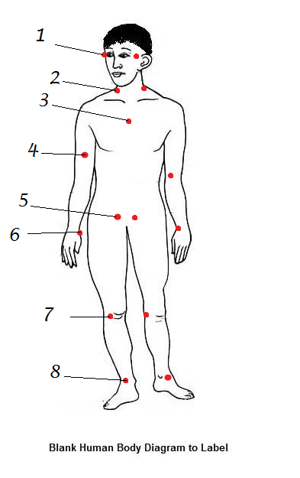
Define Pulse:___________________________________________________________________________
A(n) ___________________pulse must be taken with a stethoscope. The ____________________ pulse site is the most common place to take a pulse. The pulse site used to take BP___________________________.
*Complete the student challenge on page 159 and record your results below:

