MEDICAL TERMINOLOGY NOTES
2020-2021

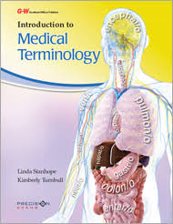

Access the online textbook:
  - www.g-wonlinetextbooks.com
    - Login: fisd62
    - Password: imt17
      - “go to my textbooks/bookshelf”

Attach course guide here:

CHAPTER 1: THE BASICS AND THE BODY
Word Parts (define all prefixes, suffixes, and root words):

Word Part | Definition | Word Part | Definition

CHAPTER 1: THE BASICS AND THE BODY

Additional notes (class rules, etc.)

CHAPTER 1: THE BASICS AND THE BODY

Anatomy-
Physiology-
Body Planes-
Body Directions-

Anatomical Position (also known as _________________________position):
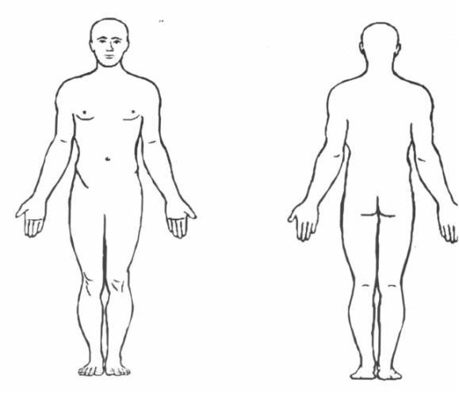
Body Planes (define- what does each plane divide the body into?)
- Sagittal-
  - Midsagittal-
- Frontal/Coronal-
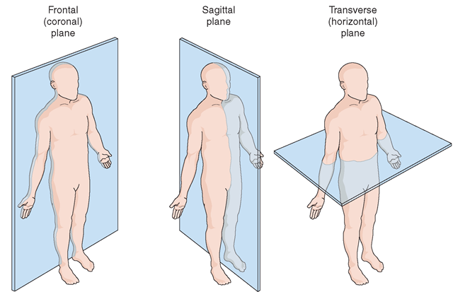
- Transverse-

CHAPTER 1: THE BASICS AND THE BODY

Body Directions (define)
- Ventral-
- Dorsal-

- Anterior-
- Posterior-

- Superior-
- Inferior-

- Medial-
- Lateral-

- Proximal-
- Distal-

- Caudal-
- Cephalic-

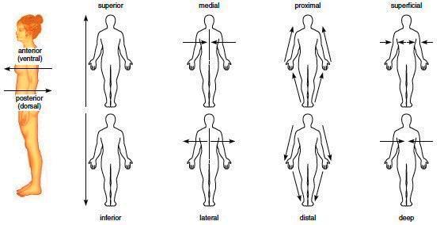

CHAPTER 1: THE BASICS AND THE BODY
Body Cavities (describe each and list organs they may contain)

_______________Cavities:
- Cranial-
- Spinal-

________________Cavities:
- Thoracic-
- Abdominal-
- Pelvis-

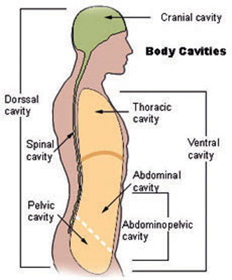

CHAPTER 1: THE BASICS AND THE BODY

Abdominal Quadrants (know the abbreviations for each) and Abdominal Regions
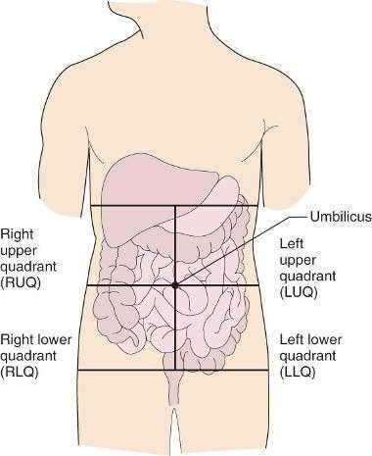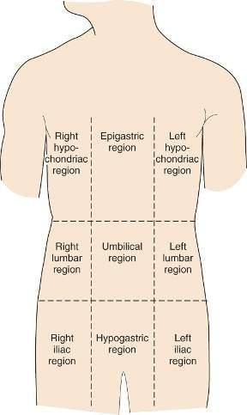

Body Organization
- Cell
- Tissue
- Organ
- Body System
- Organism

CHAPTER 1: THE BASICS AND THE BODY

The Body Systems (describe the function and parts of each)
- Integumentary

- Digestive

- Lymphatic or_______________

- Muscular

- Skeletal

- Cardiovascular or ___________________

- Respiratory

- Urinary or _________________

- Nervous

- Reproductive

CHAPTER 1: THE BASICS AND THE BODY

Patient Positions (Label each and describe what it may be used for):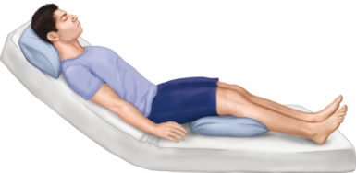 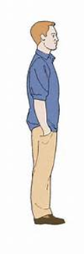
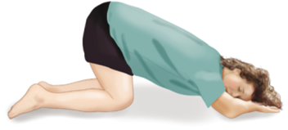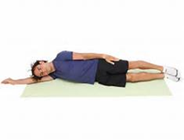

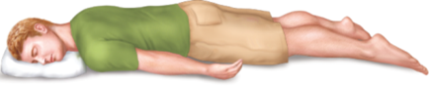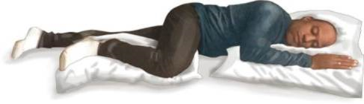
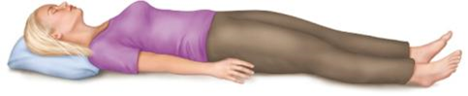

CHAPTER 1: THE BASICS AND THE BODY
Descriptive Vocabulary for Diseases/Conditions & Assessments
- Acute
- Autoimmune
- Benign
- Chronic
- Congenital
- Convalescence
- Debilitating
- Endemic
- Endogenous
- Epidemic
- Exogenous
- Genetic
- Hypersensitivity
- Idiopathic

CHAPTER 1: THE BASICS AND THE BODY

- Immunological
- Infectious
- Inflammatory
- Ischemic
- Malignant
- Metabolic
- Neoplastic
- Nosocomial
- Nutritional
- Opportunistic
- Syndrome
- Terminal
- Iatrogenic
- Inspection

CHAPTER 1: THE BASICS AND THE BODY

- Auscultation

- Signs

- Symptoms

- Palpation

- Percussion

- Olfaction

- Manifestation

- Observation

- Diagnosis

- Prognosis

Chapter 1: Additional Notes

CHAPTER 2: SKELETAL SYSTEM
Define all word parts (prefixes, suffixes, root words) and abbreviations:
Word Part | Definition | Word Part | Definition
Chapter 2: Skeletal System
Functions

Parts of the Skeletal System
- Bones:
- Joints:
- Ligaments:
- Cartilage
Anatomic landmark of bones
- Diaphysis
- Epiphysis
- proximal epiphysis
- distal epiphysis
- foramen
- process

Label the Bones of the Skeleton

cranium vertebrae femur phalanges ulna sacrum
scapula sternum tibia humerus ribs coccyx
patella carpals tarsals fibula radius calcaneus
pelvis metacarpals metatarsals maxilla mandible

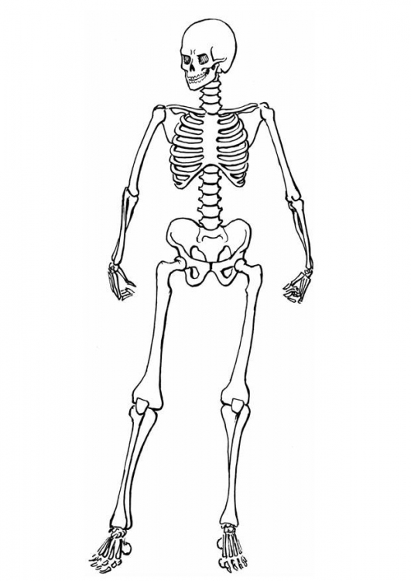

Chapter 2: Skeletal System

List the bones of the Axial Skeleton:

List the bones of the Appendicular Skeleton:

Describe and give examples of each of the bone types:
- Flat
- Irregular
- Sesamoid
- Long
- Short
Define/Describe skeletal system injuries:
- Sprain
- Dislocation
- Fracture
Describe the types of fractures (document in your journal notes if needed and draw a picture of each)

- Simple
- Compound
- Colles
- Comminuted
- Longitudinal
- Oblique
- Greenstick
- Spiral
- Stress
- Pathological
- Transverse

CHAPTER 2: SKELETAL SYSTEM DISEASES/PROCEDURES/DRUGS
Define/Describe each disease
- Kyphosis
- Lordosis
- Scoliosis
- Spina Bifida
- Osteoporosis
- Sprain
- Fracture
Define/Describe each procedure
- amputation
- cast
- bone grafting
- ORIF
- prosthesis
- CRIF
- lumbar puncture
- X-ray

CHAPTER 2: SKELETAL SYSTEM DISEASES/PROCEDURES/DRUGS

Define/Describe each therapeutic drug

- analgesic
- anti-inflammatory
- antipyretic
- narcotic
- NSAID
Describe chapter 2 skeletal careers

List the medical name for each of the bone’s common name:
- Shin:
- Heel:
- Funny bone:
- Fingers and toes:
- Breast bone:
- Collar bone

Additional chapter 2 notes:

CHAPTER 3: MUSCULAR SYSTEM
Define all word parts (prefixes, suffixes, root words) and abbreviations:
Word Part | Definition | Word Part | Definition
CHAPTER 3: MUSCULAR SYSTEM
Functions

Structures
Muscles:

Tendons:

Muscle Tissue Types
Skeletal Muscle:

Smooth Muscle:

Cardiac Muscle:

Muscle Tissue Properties:
Automaticity -

Contractility -

Elasticity -

Excitability -

Extensibility -
CHAPTER 3: MUSCULAR SYSTEM
Origin -
Insertion -
What’s the Difference?
Strain -
Sprain -

Diseases and Conditions
Adhesion -
Atrophy -
Contracture -
Hypotonia -
Muscular Dystrophy -
Tetany -
Spasm -
Rigor (rigidity) -
Tremor -

CHAPTER 3: MUSCULAR SYSTEM
Therapeutic Drug Treatments *(only write new drugs)
Antispasmodic -
Analgesic
Antipyretic
Anti-inflammatory
Narcotic
Nonsteroidal Anti-inflammatory Drug(NSAID)

Directional Movements
Abduction -
Adduction -
Inversion -
Eversion -
Hyperextension -
Dorsiflexion -
Plantar Flexion -

CHAPTER 3: MUSCULAR SYSTEM
Elevation -
Depression -
Flexion -
Extension -
Rotation -
Pronation -
Supination -
Circumduction -
Label the Muscles (page 63 in your textbook)
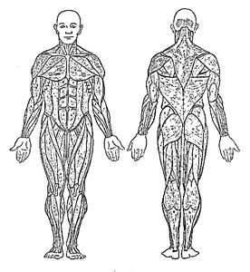

CHAPTER 3: MUSCULAR SYSTEM
*Muscle Functions: Define/Describe the muscle functions in your notes from the chart on page 68 in your textbook

Muscle Location Primary Functions
frontalis
trapezius
deltoid
pectoralis major
triceps brachii
biceps brachii
latissimus dorsi
abdominal muscles
gluteus medius
gluteus maximus
sartorius
biceps femoris (hamstring)
rectus femoris (quadricep)
gastrocnemius
tibialis anterior

Define/describe chapter 3 careers

Additional notes

CHAPTER 4: INTEGUMENTARY SYSTEM
Define all word parts (prefixes, suffixes, root words) and abbreviations:
Word Part | Definition | Word Part | Definition
CHAPTER 4: INTEGUMENTARY SYSTEM
Functions of the Skin

Layers of the Skin (using your textbook fill in the blanks & label the diagram below)
- Epidermis

- Dermis

- Subcutaneous

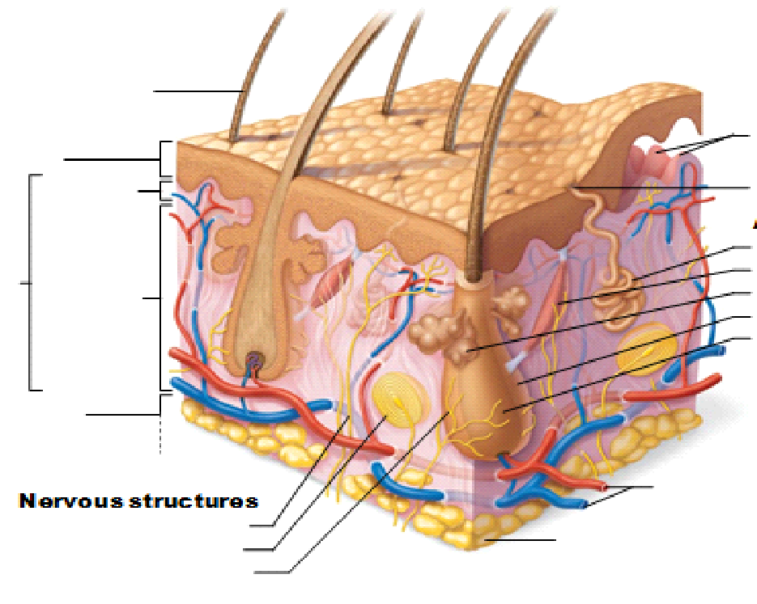

CHAPTER 4: INTEGUMENTARY SYSTEM
Accessory Organs
- Glands

- Hair

- Nails
Diseases and Conditions
- Burns:
  - First Degree -
  - Second Degree -
  - Third Degree -
- Acne –
- Albinism –
- Alopecia –
- Cicatrix –
- Cyanosis –
- Ecchymosis –
- Eczema –
- Gangrene –
- Keloid –
- Impetigo –
CHAPTER 4: INTEGUMENTARY SYSTEM
- Cancerous Lesions:
  - Basal Cell Carcinoma –
  - Kaposi’s Sarcoma –
  - Malignant Melanoma –
    - ABCDE Rule –
  - Squamous Cell Carcinoma –

- Non-cancerous Lesions:

  - Cyst –

  - Nevus –

  - Nodule –

  - Papule –

  - Polyp –

  - Pustule –

  - Ulcer –
Skin Conditions (continued)
- Psoriasis –

- Purpura –

- Scabies –

- Scleroderma –

- Tinea –

- Urticaria –

- Varicose veins –

- Vitiligo –

- Wart –

CHAPTER 4: INTEGUMENTARY TESTS, PROCEDURES AND THERAPIES
(Describe each & list other names/”also called”)
- Allergy Skin Tests
  - Scratch Test –
  - Intradermal Skin Test –
- Biopsy
  - Excisional biopsy -
  - Incisional biopsy -
  - Exfoliative cytology -
  - Needle biopsy -
  - Punch biopsy -
- Autograft -
- Blepharoplasty –
- Cauterization –
- Cryosurgery –
- Debridement -
- Dermabrasion –
- I & D -
- Lipectomy –
- Liposuction –
- Mohs Surgery –
- Sclerotherapy –
CHAPTER 4: INTEGUMENTARY PROCEDURES AND THERAPIES
Therapeutic Drugs (description, examples, what does it treat?)
- Anesthetic –
- Antibiotic –
- Antifungal –
- Antipruritic -
- Antiviral –
- Biologic -
- Corticosteroid –
- Immunosuppressant –
Chapter Careers (describe each)

Additional Notes:

CHAPTER 5: THE BLOOD, LYMPHATIC & IMMUNE SYSTEMS
Define all word parts (prefixes, suffixes, root words) and abbreviations:
Word Part | Definition | Word Part | Definition
CHAPTER 5: THE BLOOD, LYMPHATIC & IMMUNE SYSTEMS

Blood
Function(s):

Structure/Parts of the Blood (list medical name of each blood cell, the abbreviation, and its function)
Blood Cells-
Blood Cell | Abbreviation | Medical Name | Function
Red Blood Cell
White Blood Cell
Platelet

Plasma-

Lymphatic/Immune Systems
Functions:

CHAPTER 5: THE BLOOD, LYMPHATIC & IMMUNE SYSTEMS
Lymphatic Structures (describe each, other names they are called, and their function)

- Lymph
- Lymph vessels
- Lymph nodes
- Tonsil
- Thymus
- Spleen
- Liver
Immune System Structures
- T Cells (list the types)

- B Cells (describe)

CHAPTER 5: THE BLOOD, LYMPHATIC & IMMUNE SYSTEMS
Define
- Immunity
- Natural Immunity
- Acquired Immunity
- Acquired Active Immunity (list examples)
- Acquired Passive Immunity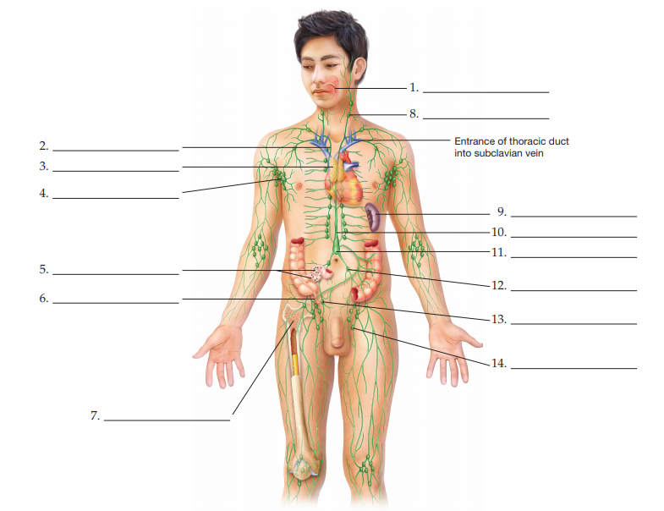
CHAPTER 5: THE BLOOD, LYMPHATIC & IMMUNE PROCEDURES AND THERAPIES
Describe each & list other names/”also called”
Classifications of Diseases and Conditions (pg. 129-131)
- Acute
- Chronic
- Congenital
- Endemic
- Epidemic
- Genetic
- Ischemic
- Nosocomial
- Terminal
Tests/Procedures (pg. 132-133)
- Apheresis
- Coagulation Test
- Complete Blood Count (CBC)
- Crossmatching
- Red Blood Cell Morphology
- Serology Test

CHAPTER 5: THE BLOOD, LYMPHATIC & IMMUNE PROCEDURES AND THERAPIES
Surgical Procedures/Therapeutics (description, examples, what does it treat?) (pg. 134-136)
- Antibiotic
- Antifungal
- Antiviral
- Corticosteroid
- Cytotoxic Drug
- Immunosuppressant

Describe chapter careers:

CHAPTER 6: CARDIOVASCULAR SYSTEM
Define all word parts (prefixes, suffixes, root words) and abbreviations:
Word Part | Definition | Word Part | Definition
CHAPTER 6: CARDIOVASCULAR SYSTEM
Functions of the cardiovascular system:

The 3 major structures of the Cardiovascular System (list):

Chambers of the Heart
*Be able to label (know location of each)

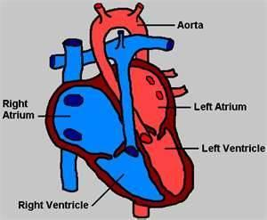
What is the aorta? (hint: type of structure/function…what is special about it)

Muscular Layers of the Heart (label the diagram)
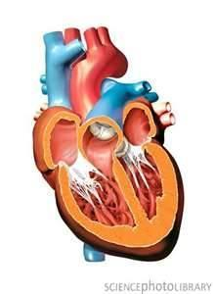

CHAPTER 6: CARDIOVASCULAR SYSTEM
Describe the heart (first) and its parts:

- epicardium
- myocardium
- endocardium
- chambers of the heart (list)

- List the four valves of the heart

Define
- circulation:

  - pulmonary

  - systemic:
List the pathway as blood flows through the heart:

CHAPTER 6: CARDIOVASCULAR SYSTEM
- conduction:

- blood pressure:
  - systolic BP:
  - diastolic BP:
  - sphygmomanometer:

Define chapter careers:

CHAPTER 6: CARDIOVASCULAR SYSTEM
Label the Pulse Points
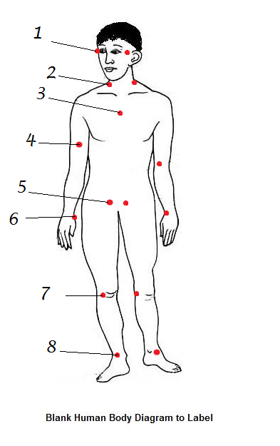

Pulse:_____________________________________________________________________
Which Pulse point is used to take blood pressure:__________________________________
Which pulse point requires a stethoscope:______________________________________
Most common pulse point:____________________________________

CHAPTER 6: CARDIOVASCULAR SYSTEM PROCEDURES AND THERAPIES
(Describe each & list other names/”also called”)
Classifications of Diseases and Conditions (pg. 154-158)
- Aneurysm
- Angina
- Cardiac Tamponade
- Congestive Heart Failure (CHF)
- Coronary Artery Disease (CAD)
- Atherosclerosis
- Arrhythmia
- Bradycardia
- Tachycardia
- Shock
- Embolus
- Thrombus
- Heart Murmur
- Hypertension
- Hypotension
CHAPTER 6: CARDIOVASCULAR SYSTEM PROCEDURES AND THERAPIES
- Diagnostic Tests/Procedures (pg. 159-161)
- Angiogram
- Cardiac Catheterization
- Auscultation
- Holter Monitor
- Stress Test
Surgical Procedures/Therapeutics (description, examples, what does it treat?) (pg. 161-166)
- Cardioversion
- Defibrillation
- Pacemaker
- Heart Transplant
- Angiotensin-Converting (ACE) Inhibitor
- Antianginal
- Anticoagulant
- Antihypertensive
- Antiarrhythmic
- Beta Blocker
- Calcium Channel Blocker
- Diuretic
- Hypolipidemic
- Thrombolytic
- Vasoconstrictor
- Vasodilator
CHAPTER 6: CARDIOVASCULAR SYSTEM

DRAW THE HEART

- Draw the heart below labeling the following structures:
Bicuspid Valve Ventricles ( right & left) Pulmonary veins Pericardium
Aortic valve Atria (right & left) Pulmonary arteries Myocardium
Septum Vena Cava (superior & inferior) Ascending Aorta Descending Aorta
Endocardium AV node SA node Tricuspid valve
Pulmonary valve

- Show blood flow through the heart with BLUE arrows for deoxygenated blood and RED arrows for oxygenated blood.

CHAPTER 7: RESPIRATORY SYSTEM
Define all word parts (prefixes, suffixes, root words) and abbreviations:
Word Part | Definition | Word Part | Definition
CHAPTER 7: RESPIRATORY SYSTEM
Label the following structures (listed below) of the Respiratory System:
Nasal cavity Mouth Pharynx Lung
Lung Bronchi Alveoli Diaphragm
Larynx Trachea

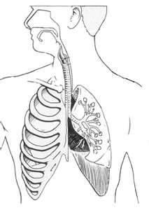

CHAPTER 7: RESPIRATORY SYSTEM
List the common name for each of the following:
trachea________________________________________________
pharynx________________________________________________
larynx__________________________________________________
What are the functions of the Respiratory System?

Describe the structures of the respiratory system
- Mouth/Nose (nasal/oral cavity)
- Pharynx
- Larynx
- Trachea
- Epiglottis
- Bronchi
- Lungs
- Alveoli
- Diaphragm

CHAPTER 7: RESPIRATORY SYSTEM
Define
- inspiration
- expiration
- respiration
  - internal
  - external
- ventilation
(Describe each & list other names/”also called”)
- Cheyne-Stokes Respiration -
- Hyperventilation -
- Orthopnea -
- Aspiration -
- Sputum -
- Sleep Apnea -
- Pleural Effusion -
- Chronic Obstructive Pulmonary Disease -
- Emphysema –

CHAPTER 7: RESPIRATORY SYSTEM DISEASES/CONDITIONS,
PROCEDURES & TREATMENTS
- Chronic Bronchitis -
- Common Cold -
- Croup -
- Asthma -
- Influenza -
- Pneumonia -
- Cystic Fibrosis -
- Pulmonary Embolism -
- Tuberculosis -
Describe/define chapter 7 therapeutic drugs

Define/describe chapter 7 careers

Additional Notes

CHAPTER 8: DIGESTIVE SYSTEM
Functions of the Digestive System

CHAPTER 8: DIGESTIVE SYSTEM
Define all word parts (prefixes, suffixes, root words) and abbreviations:
Word Part | Definition | Word Part | Definition
CHAPTER 8: DIGESTIVE SYSTEM
Parts of the Digestive System
Oral Cavity
Mouth-
Teeth-
Tongue-
Salivary Glands-
Pharynx -

Esophagus –

Stomach –

Small Intestine –

Large Intestine (Colon) -

CHAPTER 8: DIGESTIVE SYSTEM
Rectum -

Feces -

Accessory Organs of the Digestive System
Liver -

Gallbladder -

Pancreas -

List that pathway food travels through the digestive tract:

CHAPTER 8: DIGESTIVE SYSTEM
Label the Digestive System using pg. 207 in your textbook
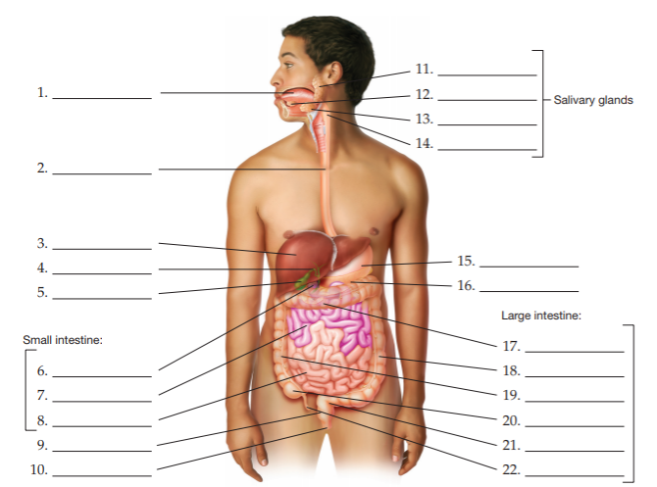

CHAPTER 8: DIGESTIVE SYSTEM
Diseases and Conditions of the Digestive System pg. 214-220
GERD –
Pyrosis –
Peptic Ulcers –
Anorexia Nervosa –
Bulimia Nervosa –
Obesity –
IBS –
IBD –
Hernia –
Dental Caries –
Celiac Disease –
Hepatitis –
Cirrhosis –

CHAPTER 8: DIGESTIVE SYSTEM
Signs and Symptoms of Digestive Conditions pg. 220-221
Ascites –
Constipation –
Diarrhea –
Emesis –
Halitosis –
Nausea –
Regurgitation –
Dehydration –

Therapeutic Drugs:

Chapter Careers:

Answer the following:
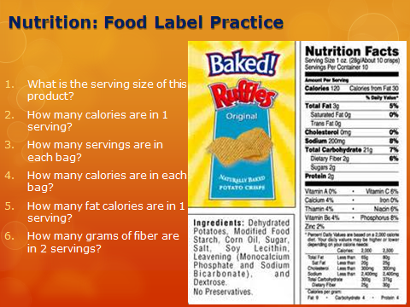
CHAPTER 9: NERVOUS SYSTEM
Define all word parts (prefixes, suffixes, root words) and abbreviations:
Word Part | Definition | Word Part | Definition

CHAPTER 8: NERVOUS SYSTEM

Function(s) of the Nervous System
- sensory input
- integration
- motor output
Describe the parts of each the main function of each system
CNS-
PNS-
Describe each structure and its function
Brain-
- occipital lobe-
- temporal lobe-
- frontal lobe-
- parietal lobe-
- cerebrum-
- diencephalon-
  - thalamus
  - hypothalamus
  - pineal

CHAPTER 9: NERVOUS SYSTEM

- brain stem-
  - pons
  - midbrain
  - medulla oblongata
Spinal Cord:
- Function-
- What protects it?
- What is white matter?
- What is gray matter?
Nerves:
- Function-
- Neuron-
- Afferent-
- Efferent-
Meninges:

CHAPTER 9: NERVOUS SYSTEM DISEASES AND CONDITIONS

Somatic(define)
- Aneurysm
- Amyotrophic Lateral Sclerosis (AMS)
- Syncope
- Cerebral Palsy
- Guillain Barre
- Multiple Sclerosis (MS)
- Transient Ischemic Attack (TIA)
- Stroke
- Bell’s Palsy
- Migraine
- Concussion
- Paralysis
- Paraplegia
- Quadriplegia
- Hemiplegia
- Paresthesia
- Spina Bifida
- Hydrocephalus
- Shingles
- Coma

CHAPTER 9: NERVOUS SYSTEM DISEASES AND CONDITIONS
- Seizure
- Aura
- Epilepsy
  - Grand Mal Seizure
  - Petit Mal Seizure
  - Focal Seizure
- Dementia
- Amnesia
- Delirium
- Meningitis
- Alzheimer’s Disease (AD)
- Parkinson’s Disease (PD)
- Tetanus (_____________)
Mental(define)
Anxiety Disorders
- Panic Disorder
- Post-Traumatic Stress Disorder (PTSD)
- Obsessive Compulsive Disorder (OCD)
- Phobia

CHAPTER 9: NERVOUS SYSTEM DISEASES AND CONDITIONS
- Generalized Anxiety Disorder (GAD)
- Developmental Disorders
- Dyslexia
- Attention Deficit Hyperactivity Disorder (ADHD)
- Autism Spectrum Disorder (ASD)
- Intellectual Disorder (ID)
- Mood Disorders
- Bipolar (Manic Depressive Disorder)
- Depression
- Seasonal Affective Disorder (SAD)
- Psychotic Disorders
- Postpartum Psychosis
- Eating Disorders
- Anorexia Nervosa
- Bulimia Nervosa
CHAPTER 9: NERVOUS SYSTEM TESTS AND PROCEDURES
- EEG
- Cerebral Angiography
- Lumbar Puncture
- PET
- Babinski Sign
- DTR
- CSF shunt
- Carotid endarterectomy
- Nerve block
- CBT
- ECT
- Light therapy
- Psychotherapy

*Draw the flowchart from page 249 of your textbook. Be sure to be able to describe the relationship between the CNS and PNS

Chapter 9: The Nervous System
*Fill in the chart with the correct disease, condition or therapeutic medication*
(Conditions are either somatic or a specific mental class/Drugs are somatic or antipsychotic)

Name | Type of Disorder or  Class | Effect on the Body
sedative  (example) | Somatic  Drug | Produces a soothing or restful effect
 |  | Usually a temporary condition that causes one side of the face to droop. Can be caused by a virus.
PTSD

 |  | Antianxiety drug
 |  | Known as a “mini stroke” and is a warning sign of a CVA caused by a brief stoppage of blood flow to the brain.
 |  | Learning disorder causing one to have difficulty recognizing and understanding written language
Neuroleptic

Medication that is used to temporarily relieve or
Deaden pain.

Name  (define abbreviations) | Type of Disorder or  Class | Effect on the Body
Schizophrenia

 |  | Drug that increases activity in the nervous system
 |  | Disability characterized by difficulty communicating with others, making eye contact, and focusing beyond oneself.
Bulimia nervosa

 |  | Congenital defect where the membrane that is supposed to cover the spinal cord protrudes outside the body through a gap in the spine.
Antianxiety

Postpartum Psychosis

Progressive disorder of nervous system with tremors, bradykinesia, muscle rigidity, irregular
gait and mask-like facial appearance

hypnotic

Name  (define abbreviations) | Type of Disorder or  Class | Effect on the Body
Shingles | Somatic Disorder | .
 |  | Also known as a concussion
OCD

 |  | Example of this drug is aspirin. Relieves pain and includes both prescription and nonprescription mediations
Phobia

 |  | Intense headache causing pain in one area of the head, nausea, and light sensitivity
 |  | Characterized by memory loss, poor language expression and inability to care for oneself due to progressive mental deterioration.
ID

Name  (define abbreviations) | Type of Disorder or  Class | Effect on the Body
 |  | Produces a soothing or restful effect
Hydrocephalus

 |  | Disorder where person is easily distracted and hyperactive. Often interferes with performance at work or school.
Narcotic

 |  | Type of CVA that occurs when a blood vessel ruptures and bleeding occurs in the brain
 |  | Type of seizure that is characterized by violent muscle contractions. Also known as a tonic-clonic seizure
MS

SAD

Additional notes:

CHAPTER 10: SPECIAL SENSES

Define all word parts (prefixes, suffixes, root words) and abbreviations:
Word Part | Definition | Word Part | Definition
CHAPTER 10 SPECIAL SENSES

Function of the Special Senses

Describe the following structures of the eye and define its function

Conjunctiva-
Sclera-
Choroid-
Iris-
Pupil-
Lens-
Ciliary Body-
Aqueous Humor-
Vitreous Humor-
Retina-

CHAPTER 10: SPECIAL SENSES

Photoreceptors-
Rods-
Cones-
Macula-
Optic Nerve-
Optic Disc-
Fovea Centralis-
Lacrimal Glands-
Lacrimal Canaliculi-
Lacrimal Sac-
Lacrimal Duct-

CHAPTER 10: SPECIAL SENSES

The Ear: Explain each area (outer, middle, inner) and its function

Describe the structures of the ear (list other names for the structures if needed):

Auricle-

Auditory Canal-

Ceruminous glands
Cerumen-
Tympanic Membrane-

Auditory Ossicles-
Malleus-
Incus-
Stapes-
Eustachian Tubes-
Labyrinth-
Cochlea-

CHAPTER 10: SPECIAL SENSES

Organ of Corti-
Vestibule-
Semicircular Canals-
Oval Window-
Round Window-
Vestibulocochlear Nerve-
The Nose: Describe the following structures and define their function:

Olfactory Receptor Cells-
Olfactory Nerve-
Olfactory Bulb-
Describe how the olfactory cells are uniquely “wired”-

CHAPTER 10: SPECIAL SENSES

The Tongue:

What type of tissue makes up the tongue?

What does the term stratified mean?

What does the term squamous mean?

What does the term mastication mean?

What does the term deglutition mean?

Describe the following structures and their functions:

Papillae-
Taste Buds-
Gustatory Sense-

CHAPTER 10: SPECIAL SENSES

Skin/Touch:

What 4 sensations are detected by the sense of touch?

Describe the location of each type of sensory detector.

Diseases and Conditions of the Eye (list common names in addition to description)
- amblyopia
- cataract
- glaucoma
- hordeolum
- nystagmus
- hyperopia
- myopia
- presbyopia
- strabismus

CHAPTER 10: SPECIAL SENSES
Diseases and Conditions of the Ear (list common names in addition to description)
- Conductive deafness
- Nerve deafness
- Impacted cerumen
- Meniere’s disease
- tinnitus
Other Disease and Conditions
- ageusia
- anosmia

Diagnostic Tests and Procedures (describe and note what sense it is used to test)
- Ishihara Color Vision Test
- Visual acuity test
- Visual field test
- audiometry
- LASIK
- Enucleation
- phacoemulsification

CHAPTER 10: SPECIAL SENSES

- Precision Nerve Exams (list all)

Medical Terminology: Special Senses
DRAW THE SYSTEM ACTIVITY

Instructions (drawings MUST be in color)
1. Draw the eye (in color) labeling the major structures listed. Define & describe each structure below. (You will need more than one drawing to complete):
- outer canthus
- inner canthus
- conjunctiva
- pupil
- iris
- sclera
- lacrimal gland
- lacrimal sac and duct
- eyelashes
- lens
- aqueous humor
- cornea
- vitreous humor
2. Draw an external/internal view of the ear labeling the structures listed. Define & describe each structure below:
- auricle
- auditory canal
- tympanic membrane
- malleus
- incus
- stapes
- semicircular canals
- vestibule
- cochlea
- eustachian tube
- external ear/middle ear/inner ear (by section)
Draw the System(s):

Additional Notes:

CHAPTER 11: ENDOCRINE SYSTEM
Define all word parts (prefixes, suffixes, root words) and abbreviations:
Word Part | Definition | Word Part | Definition

CHAPTER 11: ENDOCRINE SYSTEM
Function of the system
Hormone:
Exocrine glands:
Endocrine glands:

Label the glands and structures:

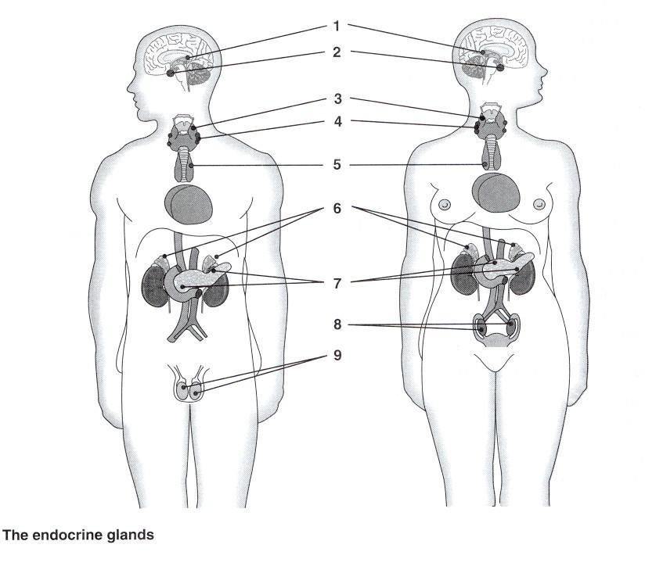
1.
2.
3.
4.
5.
6.
7.
8.
9.

CHAPTER 11: ENDOCRINE SYSTEM
Describe the main function of each gland (List the number of each in the human body and the associated hormones with each gland):
- Pituitary

  - Function
  - How many
  - Hormones
  - Associated disease/condition

- Thyroid

  - Function
  - How many
  - Hormones
  - Associated disease/condition

- Parathyroid

  - Function
  - How many
  - Hormones
  - Associated disease/condition

- Adrenal

  - Function
  - How many
  - Hormones
  - Associated disease/condition

CHAPTER 11: ENDOCRINE SYSTEM

- Thymus
  - Function
  - How many
  - Hormones
  - Associated disease/condition

- Pineal
  - Function
  - How many
  - Hormones
  - Associated disease/condition

- Pancreas
  - Function
  - How many
  - Hormones
  - Associated disease/condition

- Gonads

  - Female
    - Function
    - How many
    - Hormones
    - Associated disease/condition
  - Male-
    - Function
    - How many
    - Hormones
    - Associated disease/condition

MEDICAL TERMINOLOGY: Endocrine Diseases and Therapeutics

DISEASE | SIGNS/SYMPTOMS | GLAND/HORMONE(S) INVOLVED
Dwarfism
Tetany
Diabetic
Ketoacidosis
Hirsutism

Thyrotoxicosis
Peripheral neuropathy
Exophthalmos

Hyperparathyroidism
Edema

Endocrine Careers
- Nutritionist
- Endocrinologist
- Certified Diabetes Educator
- Phlebotomist
Endocrine Therapeutic Drugs (describe, list other names/abbreviations)

- Antithyroid agents
- Hormone replacement therapy
- Human growth hormone therapy
- Insulin replacement therapy
- Oral hypoglycemic agents
- Synthetic antidiuretic hormone
- Synthetic glucocorticoids
- Thyroid replacement therapy
Endocrine Procedures (describe, list other names/abbreviations)
- Laparoscopic adrenalectomy
- Thyroid scan
- Thyroid function test
- Human gonadotropin test
- Blood serum test
- Fasting blood sugar test
- Diabetic retinopathy
- Glucose tolerance test
- Catecholamine(s) test
CHAPTER 12: URINARY SYSTEM
Define all word parts (prefixes, suffixes, root words) and abbreviations:
Word Part | Definition | Word Part | Definition
CHAPTER 12: URINARY SYSTEM
*Use your textbook to complete the notes
Describe all four functions of the urinary system (do NOT just list the function):

Describe how the following organs/structures function in the urinary system:
- Kidneys
  - term(s):
- ureters
  - term:
- (urinary) bladder
  - related term:
- urethra
  - related term
What is urine?
- related term(s):

CHAPTER 12: URINARY SYSTEM
Urinary s/s (define)
- Diuresis
- Anuria
- Enuresis
- Oliguria
- Nocturia (nocturnal enuresis)
- Urinary retention
- Incontinence
CHAPTER 12: URINARY SYSTEM DISEASES, CONDITIONS AND PROCEDURES
- Transplant
- Lithotripsy
- Nephrolithotomy
- KUB
- Intravenous Pyelogram
- Nephrolithiasis
- PKD
- Pyelonephritis
CHAPTER 12: URINARY SYSTEM DISEASES, CONDITIONS AND PROCEDURES
- Wilms tumor
- UTI
- Cystocele
- Renal hypertension
- Renal cell carcinoma
- Nephrosclerosis
- Nephritic Syndrome
- Cystolithiasis
Additional Notes:

Draw the System Activity: Urinary
Purpose: Describe and label the different parts of the system.
Materials: Paper, pencils, crayons, colored pencils
Directions: Draw and label the system including all parts listed below. Drawing must be colored – each part a different color. Define the function of the structures listed below.
Parts to be included (define/describe each):
- Kidneys - Right and Left
- Adrenal Gland
- Ureters - right and left
- Urinary bladder
- Urethra
- External urethral orifice
- Inferior Vena Cava (draw only)
- Abdominal aorta (draw only)
- Renal vessels: veins/arteries (draw only)
- Prostate gland (describe location & function only)

Draw the System:

CHAPTERS 13: MALE REPRODUCTIVE SYSTEM
Define all word parts (prefixes, suffixes, root words) and abbreviations:
Word Part | Definition | Word Part | Definition

Chapter 13: Male Reproductive System
Use textbook to complete
List the 3 system functions:

Organs/Structures (define and describe each)
- Testicles

  - Related terms:

- Penis

  - Related terms:

- Seminal Vesicles

- Prostate gland

- Semen

Procedures and Therapeutics

Define/Describe the following:
- Ablation
- C&S
- DRE
- Circumcision
- TSE
- ED drugs
- TUNA
- TRUS
- PSA
- Vasectomy
- Vasovasostomy
- VDRL
- antibiotics
- RPR
- orchiectomy
- Orchiopexy
- Prostatectomy
- cryosurgery
- Cholesterol level
Additional Notes:

CHAPTERS 14: FEMALE REPRODUCTIVE SYSTEM
Define all word parts (prefixes, suffixes, root words) and abbreviations:
Word Part | Definition | Word Part | Definition

Describe the following structures (function, etc.):
- Ovaries
- Uterus
- Fallopian Tubes
- Vagina
- Placenta
- Umbilical cord
- Breast/Mammary Glands
Vocabulary:
- Ovulation
- Pregnancy
- Conception
- Estrogen
- Progesterone
- Gestation
- Embryo
- Fetus
- Colostrum
- Premature birth

Label the anatomy diagrams using your textbook:
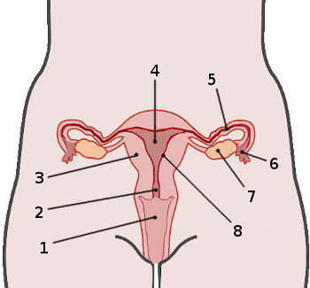
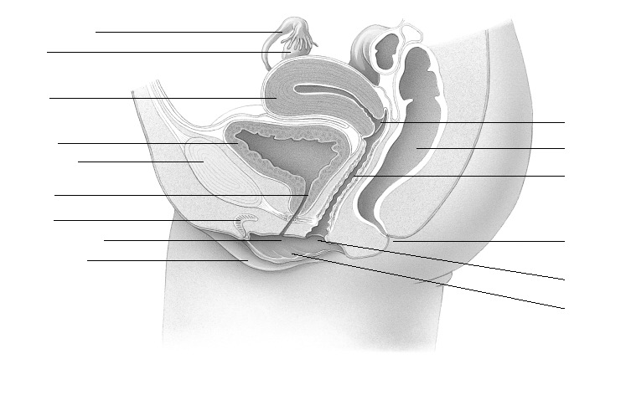
Additional Notes:

